Japan - DENAN (PSE mark) - Latest revision

Partial revision of “About Interpretation of Ministerial Ordinance for Establishing Technical Requirements for Electrical Appliances and Materials”

It was announced by METI that “About Interpretation of Ministerial Ordinance for Establishing Technical Requirements for Electrical Appliances and Materials” was revised on June 1, 2026.

The effective date of this revision is June 1, 2026.

The outline of this revision is as follows.

(1) Appendix 2 (Conduits, floor ducts and raceways including their accessories), Appendix 3 (Fuses), and Appendix 5 (Current limiters) have been consolidated into harmonized standards in Appendix 12 in line with international standards.
The grace period for Appendix 2, Appendix 3, and Appendix 5 before revisions is until May 31, 2029.
(2) To reflect the latest international technical trends, the adopted JIS standards corresponding to the international standards(IEC standards) has been replaced with the latest version of JIS standards.
- JIS standards conforming to IEC standards that have already been adopted and are to
be replaced with newer editions: 12 standards
- JIS standards to be newly adopted: none
- Number of standards to be deleted due to the expiration of the grace period: 5 standards
For further details, refer to the next page.
(3) J1000 (H14) stipulated in Appendix 12 was revised to J1000(2026) in order to ensure consistency with the technical requirements concerning products having remote control mechanisms as specified in Appendix 4 and Appendix 8.
There is no grace period for the pre-amendment version of J1000 (H14).

Harmonized standards adopted in Appendix 12:
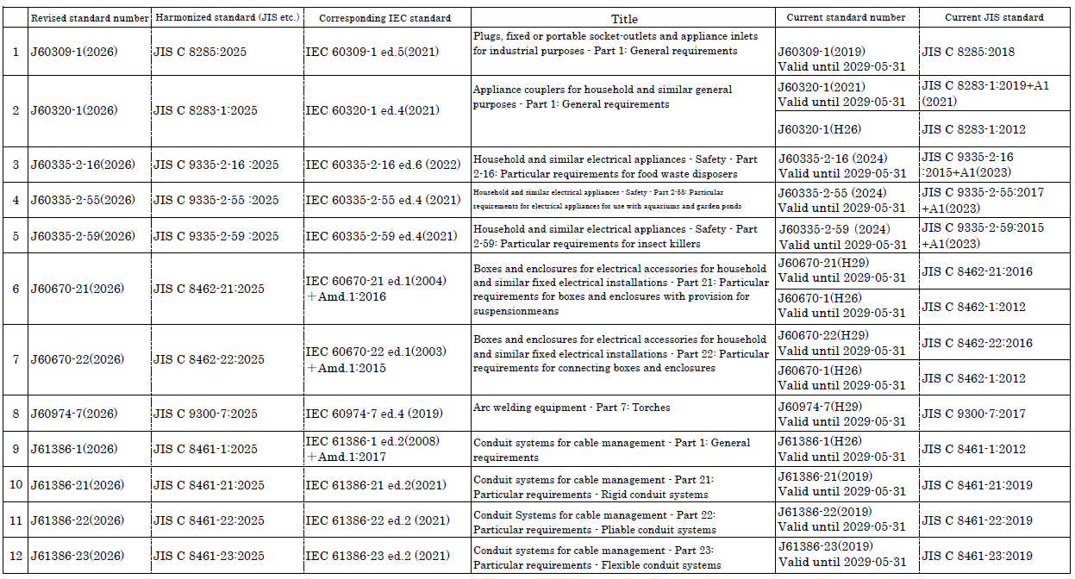

The above standards are indicated in the the table linked below.
LINK:
Appendix 12: Standards alighed with International Standards
https://www.meti.go.jp/policy/consumer/seian/denan/kaishaku/gijutsukijunkaishaku/beppyoudai12_260601.pdf

